

The Connected World

Michaela Healy 20075389



March 9, 2017

Michaela healy

20075389

Student Name: Michaela Healy

Student Number: 20075389

Course: BSc Information Technology.

Module: Information Technology

Applications.

Year: 1

Class: W1



Table of Contents

Table of Figures 2

Introduction 3

A Connected World 4

How our cities, homes and businesses are becoming more connected 5

A Mega City 7

The Internet of Things 8

What does the Internet of Things mean for ordinary people – for their homes and working lives? 9

Conclusion 11

Bibliography 12

# Table of Figures

Figure 1. Internet of Things. 3

Figure 2. Evolution of Communication. 4

Figure 3. Types of Smart Technology 5

Figure 4. Central Temple in Angkor. 7

# Introduction

Technology has and is continuing to change lives and how we connect. It has gotten to the stage where many people would struggle if they had to imagine their lives without technology. We currently live in what we call a connected world and there are many different types of technology available nowadays. Some have their advantages and disadvantages which I will be discussing in this essay. We connect through many forms of social media and technology which can be a good and bad thing. The world is getting so big that some cities have been taken over by bigger cities and become one. There are called megacities. The Internet of Things can benefit us in many ways and help us connect.

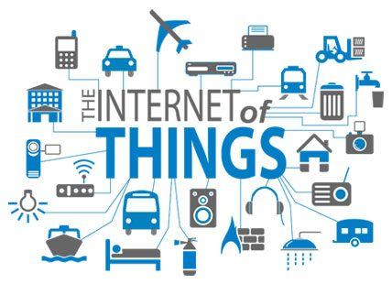

Figure . Internet of Things.

# A Connected World

There are many different explanations and opinions on what a connected world means and what it is entirely. We went from being an Agrarian society (agriculture) to an Industrial society (mass production) and now to an Information world. (Shah, 2016)

Before we had mini computers in our pockets and before technology took over, the only way we knew how to connect was by connecting and meeting up with each other in person. We used to arrange activities and take photos on cameras to get them printed out, to store them in a physical photo album, that you could keep forever and reminisce upon. There was no such thing as photoshop or editing photos of ourselves to make ourselves (what we seem to think) look better. The connected world is how we communicate and connect with each other and other people around the world.

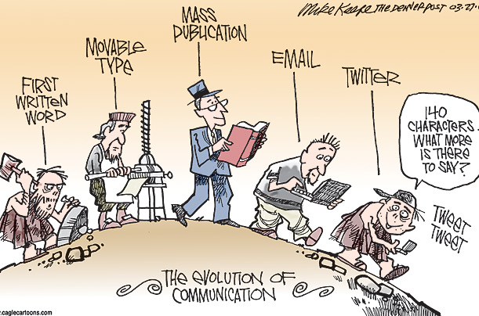

Figure 2. Evolution of Communication.

Nowadays, being in a connected world is not as simple as it used to be. People are connected on all different types of social media, the main ones being, Facebook, LinkedIn, Twitter, Instagram, and Snapchat. The opportunity to connect with people are available on these social media platforms especially Facebook, where you can add friends and connect simply by just sending them a quick message. Being in this connected world is not always the best thing to do as you can share too much information about yourself which could become dangerous. Anyone can have access to important and private information about you by going onto your social media page. They could steal your identity and ruin your reputation and this could have a great impact on your life by making you ineligible to go for jobs in the future or do certain things like taking out a mortgage.

# How our cities, homes and businesses are becoming more connected

We are living in nearly what we would call a smart city. Smart cities revolve around the idea of using new, connective technologies to make living in urban areas more cost effective, efficient, and more environmentally friendly. The smart tag is an electronic device or system that can be connected to the internet, used interactively, and is to some extent intelligent. (Doorn, 2014).

Smart technologies allow sensors, databases, and wireless access to sense, adapt, and provide for users within the environment. They can adapt automatically and modify behaviour to fit the environment, sense things with technology sensors, and provide data to analyse and conclude from to draw up conclusions from it. (Lawrence, 2008).

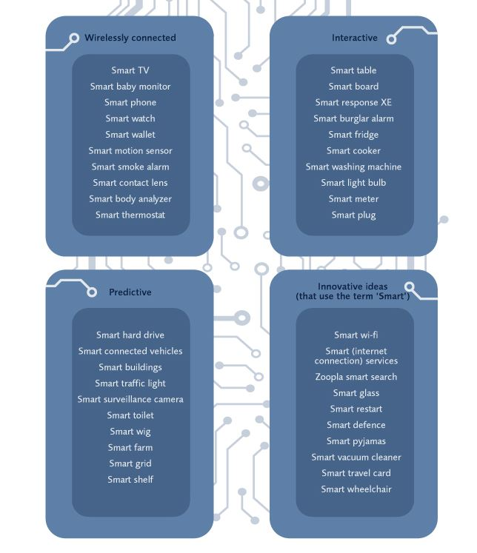

Figure 3. Types of Smart Technology

Smart technology can be used to turn on your heating while you are not at home, turn on your lights, and control most things in your house from your phone. There are smoke detectors available that can talk to you and let you know when there is a problem and alerts can be viewed from your phone. There are also smart baby monitors available that let you monitor your baby from your phone. They allow you to activate a push-to-talk mode from the app to play music to the baby, allowing you to connect and interact with them.

Nowadays, we also have Smart Parking which monitors vacant parking spaces in the city, Smart Roads which are intelligent highways with warning messages and diversions, due to climate conditions and unexpected events like accidents or traffic jams, and Smart Lighting which is intelligent weather adaptive lighting in street lights. These things help our homes, cities, and businesses to connect. (Bielsa, 2013).

Smart technology can also have its disadvantages as people who are not up to date with technology or who are just not interested in computers, might not like to live in a smart home or have things that are completely computer run, such as their heating.

The technology can be expensive and the owner would not be able to manage the system on their own. Another disadvantage is security and privacy, as the smart homes are connected through the internet and they are vulnerable to being hacked. If the system is hacked for a smart home someone would have access to the whole home and could control anything they like. For example, somebody could unlock the doors, turn off the lights and turn off security cameras which leaves you helpless and vulnerable to theft. (Society, 2013).

# A Mega City

A megacity is a metropolitan area (a region consisting of a densely populated urban area) with a total population of more than ten million people. It can be a single metropolitan area or two or more metropolitan areas, which have grown to such a big size that they now form one urban area. (Pearce, 2006). A megacity is a large city that has overtaken smaller cities to become connected. Tokyo is the biggest megacity with a population of thirty-eight million eight hundred thousand people as of 2016. There are currently about twenty-nine megacities and is expected to grow to over forty by 2030.

The number of buildings, infrastructure and inhabitants are rising as available space is continuing to decrease. The prospect of jobs and better infrastructure is currently attracting young people to urban areas which is understood to be an advantage. Some more advantages are that there are more options in megacities such as more restaurants and places to eat, more places to socialise and there are more opportunities available. Megacities can be good for businesses as there is a range of good services available for them in the area and they would not have to use multiple locations to get resources.

More disadvantages are that the quality of life can lower as the cost of living will be higher and there may be a low quality of public services as there will be many people using them. Megacities are highly polluted areas due to the increase in population who use fossil fuel power in their everyday lives to complete tasks such as driving to work and heating their homes. The higher number of people means there is a higher usage of fossil fuel which releases CFCs such as methane which damages the ozone layer causing damage to the environment. In the future, more people will be living in smaller houses because the demand for living space is rising and it is a challenge to find space. (SE, 2015).



Figure 4. Central Temple in Angkor.

Megacities are not a thing of the present they have in fact been around since the ninth century. Recent studies have uncovered the over grown city of Angkor, Cambodia which is believed to once have been the size of Los Angeles. Archaeologists have used modern technology such as aerial laser surveys otherwise known as airborne scanning to uncover the lost city. (Wainwright, 2016).

# The Internet of Things

The Internet of Things is a network of objects that contain a variety of electronic systems which allow them to gather and exchange data and communicate with each other. It can also refer to how computing devices, machines, objects, and other devices connect to each other. In 2016, there were over 20 billion things connected to the internet and is expected to jump to 50 billion by 2020. (Drew, 2016).

There are many advantages and disadvantages of IoT (The Internet of Things). Some advantages are that machine-to-machine interaction is more efficient and enables people to connect and to focus on other jobs. IoT helps make problems associated with bottlenecks, breakdowns, and system damages less expensive and cost effective by simplifying the problem and providing software that can cope with issues and bugs. There is a lot of information available on the internet and the more data you have, the easier it is to make decisions and it saves time and can be convenient as well. Technology could replace humans who monitor and maintain supplies which in future, could be a good financial aspect of IoT and would be less expensive.

Some disadvantages could be that IoT is complex and there are opportunities for failure with complex systems. There could be a bug in the system and it could affect all the users at once which would be frustrating and inconvenient. Privacy can also be a big issue as all the data must be encrypted or kept private so that your financial status or personal information is not taken advantage of and is secure. There is also a chance that software could be hacked and all your personal information is misused. There are major problems of IoT. (Prateek, 2016).

# What does the Internet of Things mean for ordinary people – for their homes and working lives?

The amount of services brought to the table affect ordinary people daily. Many people use IoT (Internet of Things) every day without realising or knowing it. Sometimes ATM machines, thermostats and traffic lights are made up of IoT and ordinary people could be using these services. (Drew, 2016). IoT has the power to make your home more comfortable, energy efficient and safer. It can be used for your appliances, air-conditioning, switches, security, entertainment, doors, thermostats and even toasters. These are aimed towards saving you time, money, and energy.

We can see IoT being used in their daily lives in the following examples. Smart Coffee is a Wi-Fi enabled coffee maker. It can adjust your coffee strength, warn you when the water level is low and you can control this device from anywhere at home by using your smartphone. There is also smart lighting available and the lights switch on automatically when you enter your home. The lighting can be customised to match your mood or to save energy costs. Along with smart lighting there is also smart heating and cooling. This senses your movements, tracks them, and creates a customised temperature schedule. You can adjust this using your smartphone if you are not happy with the schedule or temperature degrees. (AppInventiv, 2016).

The Internet of Things can be used in our working lives and can make work easier, more efficient, and less cost consuming. IoT will increase productivity and efficiency by making location tracking simpler. This is currently done in hospitals where devices are all geographically tagged which saves workers time trying to find out information and saves money. Companies can track every aspect of their business from how much they have in their inventory to how many orders have been processed and locating where the products need to be sent to. There is also the connection of mobile devices, cars on the roads you drive on which will help to reduce travel time, which will enable you to get work done faster or run errands. There are helpful for people at home or in their working lives. (Sara, 2013). These thing help improve people’s working lives and creates less stress for them.Connection between the Connected World, Megacities, and the Internet of Things

The Connected World, Megacities and the Internet of Things are all connected through many ways. One of which being that they all use technology and can relate to each other. The connected world continues to develop and change with the development of technology. As technology improves and changes, the way in which we connect does as well.

In the past, people used to connect by meeting up with each other and we went from being an Agrarian society to an Information world. The bigger the cities get the less room there will be and this will result in more megacities being developed. The cities will get bigger and will end up taking over each other to become one, because space will be limited.

The Connected World and Megacities both use the Internet of Things (IoT) ad this develops a connection between them. The IoT can help to gather and exchange data and will make it easier to send data to other people in other cities or countries.

# Conclusion

We are all connected in many ways through the connected world. We connect in person, over the internet, through social media and email. Being connected over the internet can have its advantages and disadvantages such as it is quick and easy, or also your identity could be stolen. There are a lot of smart cities that exist in the world now and new technologies are being developed and have been developed, that helps us connect with each other and objects. The number of different technologies available is increasing dramatically. Smart technology helps us to stay connected even when we are not at home. It can help us stay in control of what is happening in our homes.

Some cities have a population of over ten million people and these are called megacities. It is a metropolitan area which has frown to such a big size that it now forms one single urban area. A megacity is also a large city that has taken over smaller cities to become connected.

The Internet of Things is used all around us and sometimes we do not even notice it. ATMs can sometimes be made up of IoT and so can traffic lights. Technology is all around us and we may be unaware of it sometimes.

In conclusion, technology can help us to connect and sometimes make our lives easier in some ways, but it also has its disadvantages and it may take over human jobs in the future.

Technology has become such a big part of people’s lives and some people cannot imagine their lives without it, including myself.

# Bibliography

AppInventiv, 2016. *Wordpress.* [Online]   
Available at: https://appinventiv.wordpress.com/2016/06/07/7-smart-home-ideas-enabled-by-the-internet-of-things/  
[Accessed 27 March 2017].

Bielsa, A., 2013. *Libelium.* [Online]   
Available at: http://www.libelium.com/resources/top_50_iot_sensor_applications_ranking/  
[Accessed 21 March 2017].

Doorn, M. V., 2014. *So Get It Labs.* [Online]   
Available at: http://labs.sogeti.com/wat-smart-technology-actually-mean/  
[Accessed 16 March 2017].

Drew, W., 2016. *Keyinfo.* [Online]   
Available at: http://www.keyinfo.com/pros-and-cons-of-the-internet-of-things-iot/  
[Accessed 30 March 2017].

Lawrence, A. T., 2008. *What is Smart Technology.* s.l.:IGI Global.

Osborne, C., 2016. *zdnet.* [Online]   
Available at: http://www.zdnet.com/article/innovative-inventions-of-2016-which-could-transform-our-smart-cities/  
[Accessed 16 March 2017].

Pearce, F., 2006. How Big Can Cities Get?. *New Scientist Magazine*, 17 June, p. 41.

Prateek, S., 2016. *e27.* [Online]   
Available at: https://e27.co/advantages-disadvantages-internet-things-20160615/  
[Accessed 27 March 2017].

SE, A., 2015. *Allianz.* [Online]   
Available at: https://www.allianz.com/en/press/news/studies/151130_the-megacity-of-the-future-is-smart/  
[Accessed 24 March 2017].

Shah, S., 2016. *Sociology Discussion.* [Online]   
Available at: http://www.sociologydiscussion.com/society/types-of-society-tribal-agrarian-and-industrial-society/2190  
[Accessed 14 March 2017].

Society, C. 1. -. C. a., 2013. *wordpress.* [Online]   
Available at: https://briannev.wordpress.com/disadvantages/  
[Accessed 23 March 2017].

Wainwright, O., 2016. *The Guardian.* [Online]   
Available at: https://www.theguardian.com/cities/2016/aug/16/lost-cities-6-angkor-wat-nasa-technology-khmer-megacity  
[Accessed 24 March 2017].